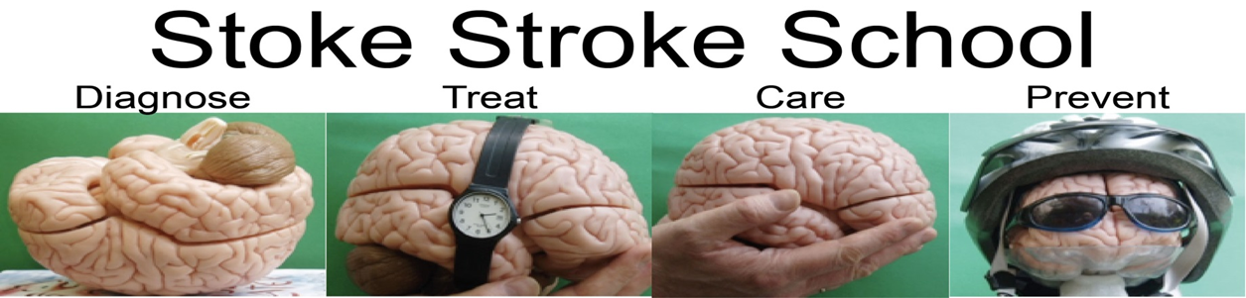
Interested in Stroke care?

Want to know more about Stroke?

What can the Stoke Management course offer?

The course offers insight into the following:
- Diagnosis of stroke – what assessments are used for diagnosis, investigations
- Treatment – from ambulance pre-alert, emergency admission, assessments and emergency treatments
- Care of stroke patients – Acute Stroke Unit care
- Secondary prevention – Medications, lifestyle changes

Course Dates 2018

Week 1 - 1 May 2019 Week 2 - 8 May 2019
Week 3 - 15 May 2019 Week 4 -22 May 2019

Further information available from Keele University or alternatively contact Caroline Lambert (caroline.lambert@uhnm.nhs.uk), Jeanette Grocott (jeanette.grocott@uhnm.nhs.uk) or Kathryn Hick (k.hick@keele.ac.uk)

